1. Azure ML (3rd Oct):

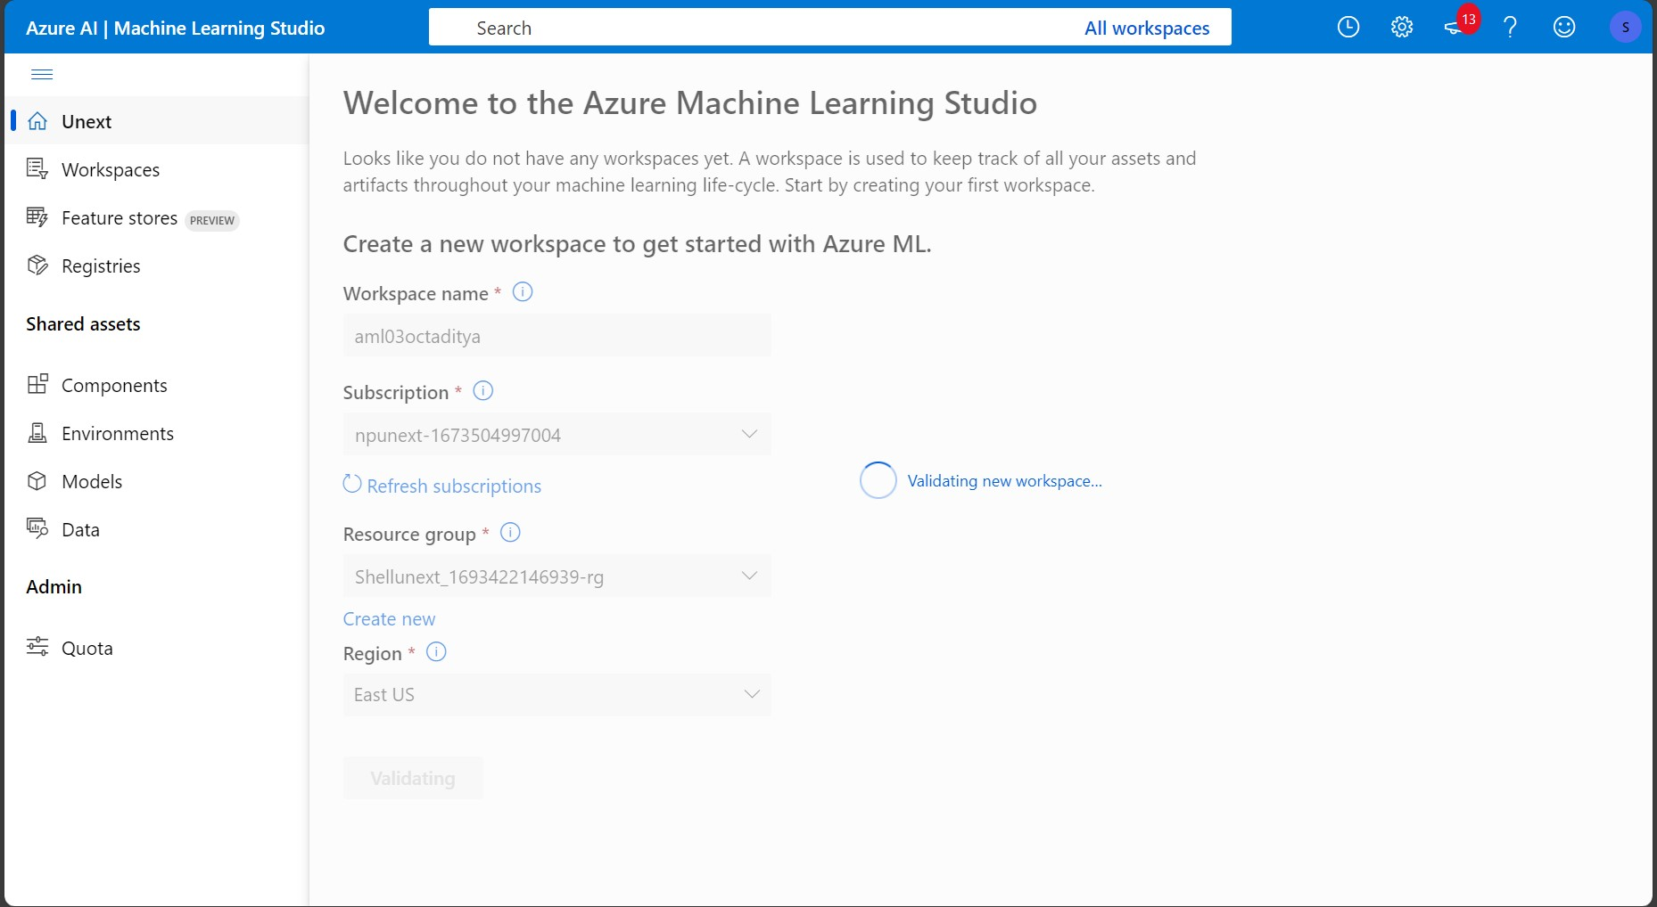

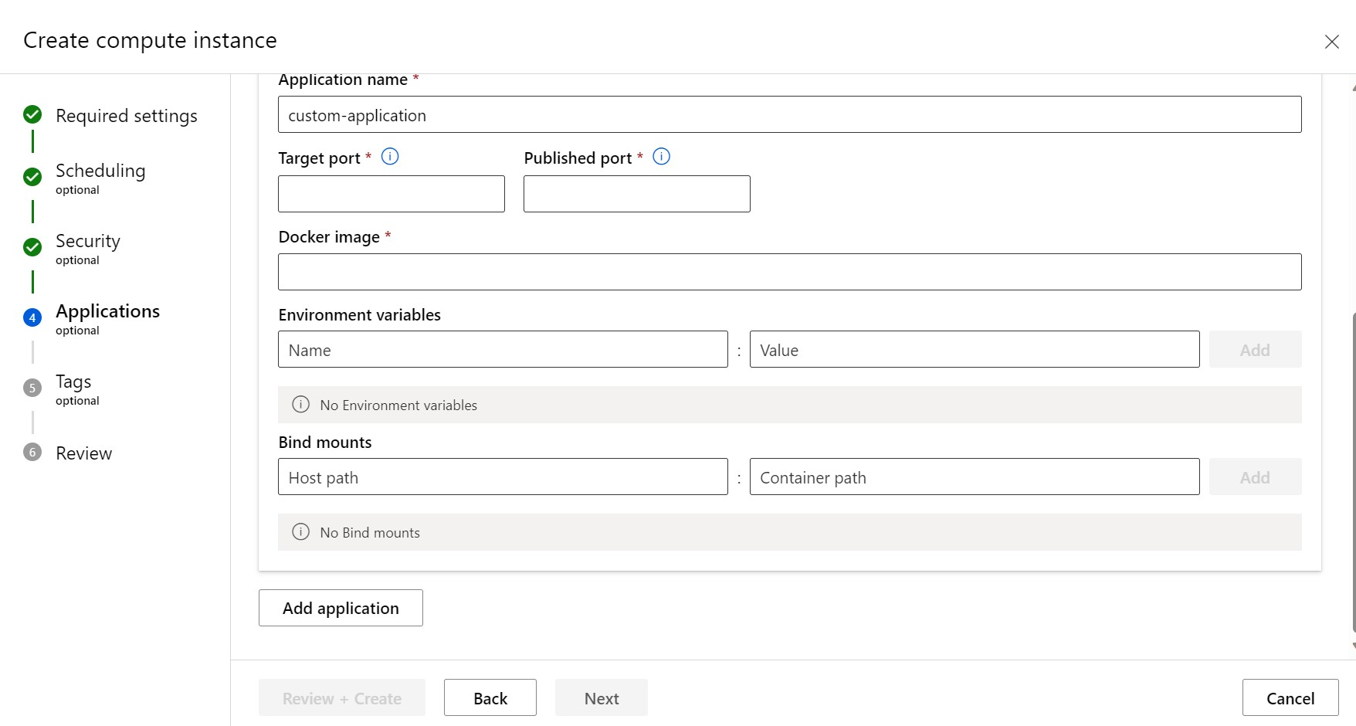

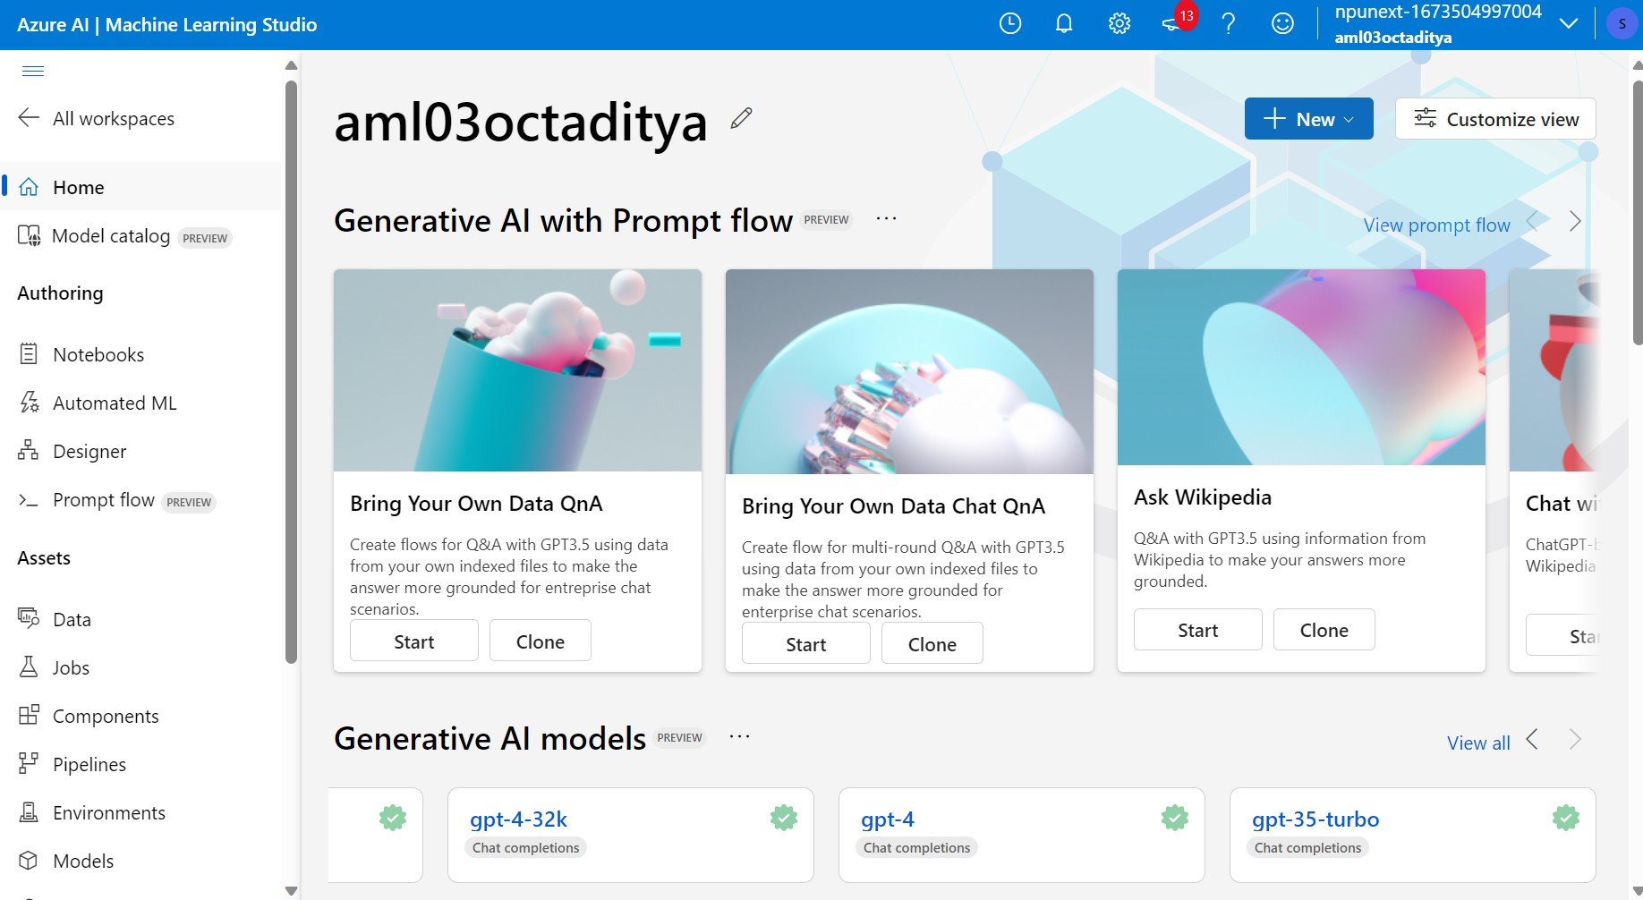

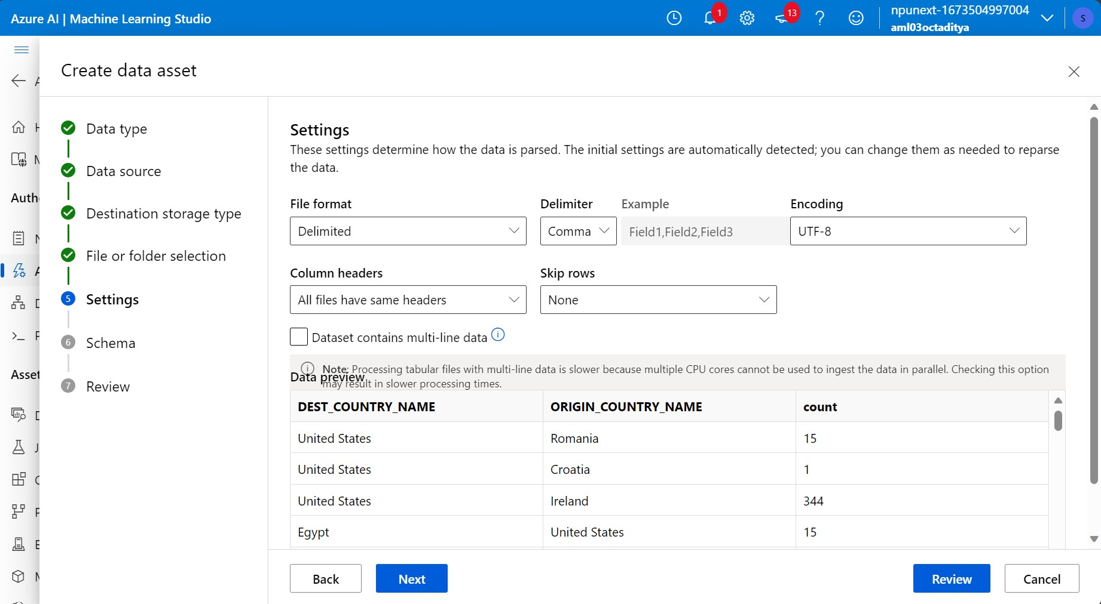

1. Azure ML (4th Oct):



